**1.2.2**

The plan: Eve can start by finding the letter frequencies for each letter. Then she can replace the most frequently used letter with an “e”. She can then use the statistic of the most common letters, digraphs, and trigraphs to fill in the rest.

Final Key:

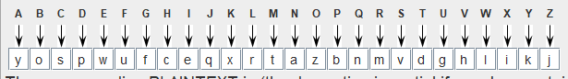

**1.3.1**

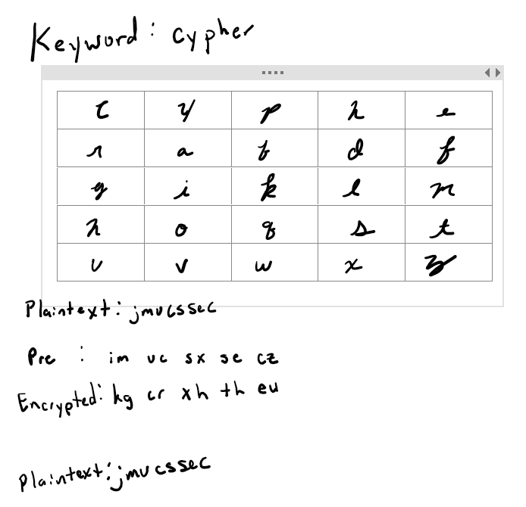

**1.3.2**

1. For the Playfair cypher it could be possible to obtain the keyword that was used to construct table. In some instances, though it may be nearly impossible to obtain the exact keyword. It would depend on the particular keyword and how many repeated letters it contained. It is fully possible to obtain the key table from the plaintext/cyphertext pairs. I start by finding pairs that contain the same letter. This tells me that the letter all appear in the same row or column. I find every instance where this occurs. At that point, I should be able to piece together some of the table with the letters that have been found to be in the same row. From here I will randomly choose pairs that have some letters in the table and some that aren’t. Reversing the encryption stage of the Playfair cypher and inserting the missing letters in their desired place.

Key table for 1.3.2:

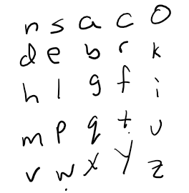

Possible keyword: NSACodeBreakChallenge

Decrypted: LETXTHEMHATEUSSOLONGASTHEYFEARUS

Let them hate us so long as they fear us

**1.4.2**

**Task 0**

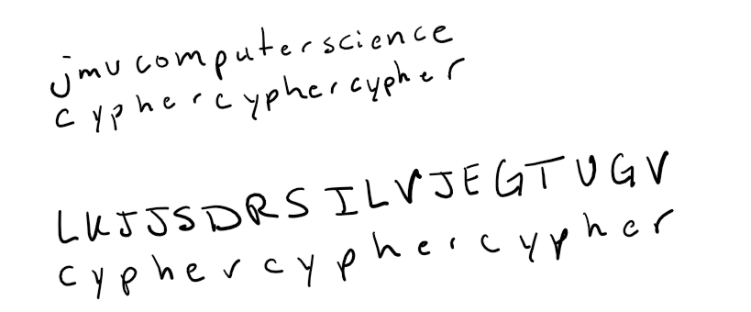

Keyword: Cypher

Encrypted: LKJJSDRSILVJEGTUGV

Unencrypted: jmucomputerscience

**Task 1**

Keyword: unitedstates

Cleartext:

mr. alexander,

how is it that the messenger arrives

here at the same time with the saturday courier

and other saturday papers when according

to the date it is published three

days previous. is the fault with you or

the postmasters?

Description of steps:

I started out by pasting the ciphertext into the java program to count the trigraph distances. I found that there were 3 trigraphs. Their distances were 72, 72, 91. To find the length of the key we are supposed to use the gcd of these three numbers. In this case though the gcd would be 1. I decided the best approach would be to assume that 91 could be either 84 or 96. This would allow the gcd(72, 96) to be 12. I guessed 12 as the length and let the program count the single letter frequencies. From there I used the method of solving substitution ciphers with letter frequency to find each set of substitution ciphers. Then taking the ciphertext that corresponded to “a” in plaintext I put each together to get the key word.

**Task 2**

Keyword: turing

Cleartext:

the idea behind digital computers may be explained by saying that these machines are intended to carry out any operations which could be done by a human computer

Description of steps:

I started this decrypting the same way as the last one. Found the trigraphs that repeated. In this case there was only one repeating trigraph with a distance of 54. This made things a little trickier. Because of this I knew the key length was equal to a multiple of 54. I immediately ruled out multiples of 1, 2, and 3 assuming that Prof Wang wasn’t going to let us off that easy. The next multiple was 6. I used this as the key length and went through the same process as task 1. Matching up most common letters with the frequently used letters in the cipher. Eventually after some shifting I found the key to be turing.